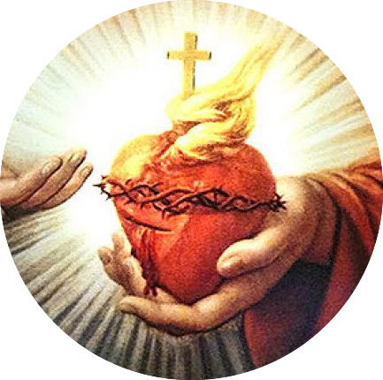
Sacred Heart Catholic Church
2508 Appleby Sand Road
Nacogdoches, TX 75965

Sponsorship Form

Name: ____________________________________________________________________________________
Address: ______________________________________________________________________________
City: ____________________________ State: _________________ Zip Code: _________________
Phone Number: ____________________________ E-Mail ____________________________________
Are You OK With Us Using Your Name As Our Sponsor (Circle One): YES NO
How would you like your name to appear:______________________________________________

Sponsorship Donation: (Circle One)

Single - $250 / Couple -$400

If you would like your business logo printed on the Sponsorship sign displayed at the festival please send a high resolution .jpeg file to shoey@catholicnac.org

Sponsorship Includes:

Single – festival sponsor collared polo, appreciation party with parish priests

Shirt Size: __________ Gender: __________
Couple – festival sponsor collared polo (x2),
Appreciation party with parish priests

Shirt Size: __________ Gender: __________
IF you would like to opt out of the Sponsorship Package, Please check this Box:

