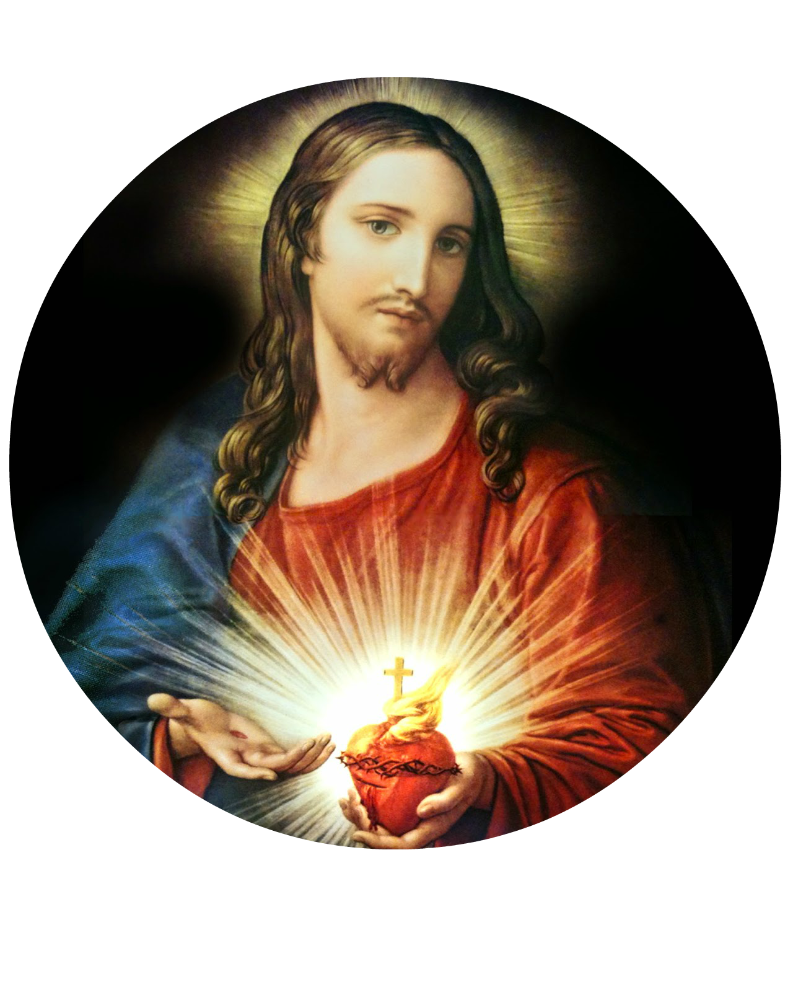
Sacred Heart Catholic Church
2508 Appleby Sand Road
Nacogdoches, TX 75965

APPLICATION TO CELEBRATE
THE SACRAMENT OF BAPTISM

REQUIREMENTS: 1. Fill out the following application
2. Submit a copy of the child’s birth certificate
3. Parents and godparents must attend pre-baptismal classes
4. If the godparents are married, they must be married in the Church, and if they are not, they must have a date to celebrate the sacrament (please meet with the priest)

Child’s Name: _____________________________________________________________________________

Date of Baptism: _________/_________/____________ Date of Birth: _________/_________/____________
Month Date Year Month Date Year

Place of Birth: _____________________________________________________________________________

PARENTS’ INFORMATION
Father’s Name: _____________________________________________ Phone: ________________________

Mother’s Name: ____________________________________________ Phone: ________________________
(Maiden)
Address: __________________________________________________________________________________

Are the parents married in the Catholic Church? Y / N

GODPARENTS’ INFORMATION
To be permitted to take on the function of a sponsor, according to the Code of Canon Law (874 §1-2), a person must:
- Have the aptitude and intention of fulfilling this function
- Be at least 16 years old
- Not be the father or mother of the one to be baptized
- Be a Catholic that has received confirmation and eucharist (a baptized person who belongs to a non-Catholic ecclesial community is not to participate except together with a Catholic sponsor and then only as a witness of the baptism).
- Living a life of Faith in keeping with the function to be taken on
- Not be bound by any canonical penalty (excommunication), legitimately imposed or declared

Do the proposed godparents meet these requirements? Y / N
Godfather’s Name: __________________________________________ Phone: ________________________

Godmother’s Name: _________________________________________ Phone: ________________________

FOR THE OFFICIAL CHURCH USE ONLY
Date of baptism class: _______________________ Signature of catechist: _______________________________________________

Date of baptism: ___________________________ Signature of minister: _______________________________________________

Comments: __________________________________________________________________________________________________

