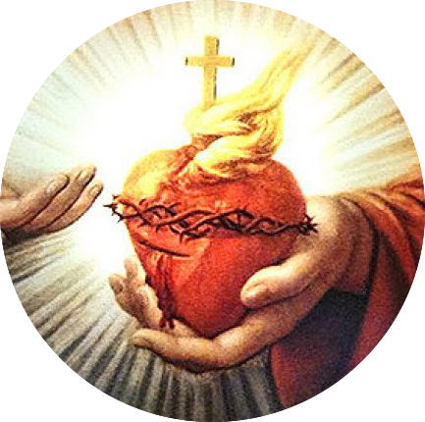
Sacred Heart Catholic Church
2508 Appleby Sand Road
Nacogdoches, TX 75965

Sponsorship Form

Name: ____________________________________________________________________________________
Address: ______________________________________________________________________________
City: ____________________________ State: _________________ Zip Code: _________________
Phone Number: ____________________________ E-Mail ____________________________________
Shirt Size: __________ Gender: __________
Shirt Size: __________ Gender: __________
Are You OK With Us Using Your Name As Our Sponsor (Circle One): YES NO
How would you like your name to appear:______________________________________________

Sponsorship Donation: (Circle One)

Single - $250 / Couple -$400

Additional Add On: 12x12 full color Business name or Logo $45

Sponsorship Includes:

Single – Festival Sponsor Collared Shirt, 8 Raffle Tickets, Appreciation Party With Parish Priests

Couple – Festival Sponsor Collared Shirt (x2), 12 Raffle Tickets,
Appreciation Party With Parish Priests

